Project Report

On

## *Online Boutique System*

**By**

1.Sawant Disha Sanjay[37]

2.Bachhav Puja Dipak[38]

3.Pagar Harshada Dattatrey[33]

**Under The Guidance Of**

Dr. Amit D. Kasliwal

**Submitted in Partial Fulfillment of T. Y. B. Sc. (Computer Science)**

**Savitribai Phule Pune University**

**2018 – 19**

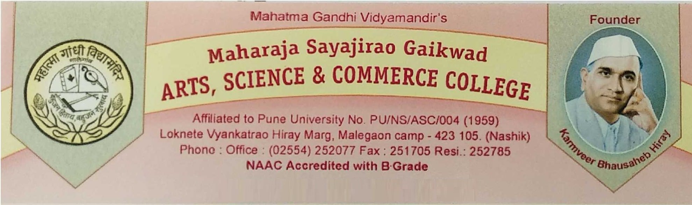

**CERTIFICATE**

This is to certify that, the project entitled _______________________________________ submitted to Department of Computer Science, is a bonafide record of work done by ___________________________________________, Roll No. ____, Uni. Seat No. _______ under my supervision for the partial fulfillment of T. Y. B. Sc. (C. S.) in Lab Course III (CS-349) during academic year 2018-2019.

Project Incharge

D. J. Deore

Internal Examiner External Examiner

**Project Progress Report**

|  |  |  |  |
| --- | --- | --- | --- |
| **Name of the student & Roll No.** | |  | |
| **Project Name** | | Online Boutique System | |
| **Sr. No.** | **Task Done** | | **Sign** |
|  | Introduction to Proposed System | |  |
|  | Working of Existing System | |  |
|  | Requirement Analysis | |  |
|  | Feasibility Study | |  |
|  | System Diagram | |  |
|  | Data Dictionary | |  |
|  | I/O Screens | |  |
|  | Testing | |  |
|  | Future Enhancement | |  |
|  | Bibliography | |  |

**Acknowledgment:**

It gives as great pleasure and satisfaction in presenting this report an our project work as part of partial fulfillment for bachelor in computer science gratitude to several people, it would have been impossible for us to carry out the desire work we like to express our sincerely thank to our department teachers for their guidance throughout project. We would like to express our heartfelt thanks to our H.O.D. Mr. D. J. Deore sir for their constant support and encouragement during these phase and forgive us valuable suggestion time to time. Last but not list we are thankful to our family member and friends for their silent cooperation and passion, and all known and unknown person who helped us in this duration.

Disha Sanjay Sawant[37]

Bachhav Puja Dipak[38]

Pagar Harshada Dattatrey[33]

**Introduction:-**

Online shopping system project is to develop a general purpose e-commerce store where any product (such as tops,jeans,blazers,party-wear) can be baught from the comfort of home through the internet.

E-commerce is fast gaining ground as an accepted and used business paradigm more and more business houses are implementing web sites providing functionality for performing commercial transaction over the web it is reasonable to say that online boutique system project report the process of shopping on the web is becoming common place.

An online store is a virtual store on the internet where customers can browse the catalog and select products of interest.The selected item may be collected in a shopping boutique at checkout time. The items in the shopping cart will be presented as an order at that online shopping system project report time , more information will be needed to complete the transacion usually the customer will be asked to fill or select a billing addresses ,a shipping address , a shipping option and payment information such as credit card number, a e-mail notification is sent to the cutomer as soon as the order is placed.

**Introduction to proposed system:-**

This system will be like a virtual supermarket online system produce . The buyer is directly online to the sellers computer usually via the internet there is no intermediary service.The internet there is no intermediary service. The sale and purchase transaction is completed electronically and interactively in real time if an intermidiary is present then the sale and purchase transaction is called electronic commerce. This web store can be implemented using various technologies such as php.

User can select the product he wants to buy and the selected product will be added to cart contains users name, contact details,product. He had selected and the amount user can search for the product through category like after selecting products user can make payment through cash on delivery or by credit card for credit card payment . After payment products will delivered to his specified address. Since this system is easily available in smart phones customer who has phones supporting android can easily use this website and can buy their products. There is no need to waiting in long queue no need of carrying heavy bags and struggling with trolleys customer can purchase products sitting at home by viewing images of different cloyhs and material products and adding in shopping cart.

**Working of existing system:-**

The present scenario for shopping is to visit the shops and market manually and then from the available product list one needs to choose the item he or she wants and then payment for the same item mainly in cash mode is done, as not every society is well educated and aware to use net banking or card modes or wallets etc.

This system is not much user friendly as one needs to go to the market physically and then select items only from the available list. So mostly it is difficult to get the product as per our desire.

Description about the products are less available and are mostly verbal only. For this type of shopping one needs to have ample amount of free time. Also not really good markets exist everywhere, so many times good markets become out of reach for certain people.

In the proposed system customers need not to go to the shops for purchasing the products. He/She can order the product he/she wishes to buy through the use of this system.

The shop owner can be the admin of the system. Shop owner can appoint officials particularly to handle this, who will help owner in managing the customers and product orders. The system also endorses a home delivery system for delivering the purchased products.

**Drawback of existing System-:**

The exiting traditional system of shopping has a large number of drawbacks such as time-consuming procedure, formation of crowd in malls, problem of bargaining, etc. These problems waste time of customers and manpower of businessmen or enterprises.

**Software Requirement**

To run this software system effectively and efficiently we will require the software like

* Web browser
* Microsoft Windows OS (7 onwards) / Linux O.S.
* WAMP- 2.1/XAMP
* PHP Version-5.3.5
* Postgresql-9.3.10-3

**Requirement analysis:**

Requirements analysis is the process of defining what the user requires from the system and defining the requirements clearly and in an unambiguous state. The outcome of the requirement analysis is the software developing activities. Thus it deals with understanding the problem goals and constraints. This specification part mainly focuses on what had been found during analysis.

A requirement is a relatively short and concise piece of information, expressed as a fact. It can be written as a sentence or can be expressed using some kind of diagram. Requirements are divided into two major types functional and non-functional.

**Functional requirements:**

Following is a list of functionalities of the system. More functionality that you find appropriate can be added to this list. And, in places where the description of functionality is not adequate, you can make appropriate assumptions and proceed.

**Fact Finding**

Fact-finding is one of the important steps toward any system development. It is essential to gather all the information and facts about an existing system to ensure that all strengths and weakness are discovered. Thus when a new system is designed as many of the weaknesses as possible are eliminated, whilst retaining the strengths. There are five general techniques available; those used depend upon the particular circumstances!

· **Sampling of Existing Documents;**

· **Interview;**

· **Observation;**

· **Questionnaires**

· **Research and Site Visits**

**1) Sampling of Existing Documents:**

To follow this particular method of fact-finding, Analyst has to study well existing documentation, forms, and files of existing system. A good analyst gets fact first from existing documentation rather than from people.

**2) Interview:**

This technique of fact-finding is most popular, productive for good analysts and most probably widely used. Interviews are a fact-finding technique where by the systems analysts collects information from individual fact to face. Interviewing can be used to find-facts; verify facts; clarify facts; general enthusiasm etc.

**3) Observation:**

Observation could be Formal or Informal. This is most effective when and analyst wants to obtain an understanding of a system. This technique used when analyst wants either participates in or watches a person perform activities to learn about the system.

**4) Questionnaires:**

This is a special purpose document that allows the analyst to collect information and opinions from respondents. Questionnaires become useful when a little information is required from a number of people.

**5) Research and Site Visits:**

Analyst has to research with data of the organisation. The data could be collect from the documents, files or from computer. Most organisations like to maintain their web site. Analyst can get data and information of their existing system from their web site.

**Feasibility study:-**

The feasibility study investigates the problem and the information needs of the stakeholders. It seeks to determine the resources required to provide an information systems solution, the cost and benefits of such a solution, and the feasibility of such a solution. The analyst conducting the study gathers information using a variety of methods, the most popular of which are:

* Interviewing users, employees, managers, and customers.
* Developing and administering questionnaires to interested stakeholders, such as potential users of the information system.
* Observing or monitoring users of the current system to determine their needs as well as their satisfaction and dissatisfaction with the current system.
* Collecting, examining, and analysing documents, reports, layouts, procedures, manuals, and any other documentation relating to the operations of the current system.
* Modelling, observing, and simulating the work activities of the current system.

The goal of the feasibility study is to consider alternative information systems solutions, evaluate their feasibility, and propose the alternative most suitable to the organization. The feasibility of a proposed solution is evaluated in terms of its components. These components are:

**Types of feasibility study:-**

**1) Technical feasibility**

**2) Economic feasibility**

**3) Operational feasibility**

**4) Social feasibility**

**1) Technical feasibility:**

The possibility that the organization has or can procure the necessary resources. This is demonstrated if the needed hardware and software are available in the marketplace or can be developed by the time of implementation.

**2) Economic feasibility:**

The economic viability of the proposed system. The proposed project's cost and benefits are evaluated. Tangible costs include fixed and variable costs, while tangible benefits include cost savings, increased revenue, and increased profit. A project is approved only if it covers its cost in a given period of time. However, a project may be approved only on its intangible benefits such as those relating to government regulations, the image of the organization, or similar considerations.

**3) Operational feasibility:-**

This is about acceptance of the new system by the existing end-users and employees of the system and author. The website is aiming at employees and now-a-days all of them are aware of web browsing. If any person does not have any idea of web browsing, he/she will be trained to use the system within one hour time. So, the system can easily be accepted by any kind of end-user. Hence the proposed system is technically feasible.

**4) Social feasibility:-**

In this social feasibility the user can easily access our system means our system means our system friendly to our uses or customers .Add also increase their skill .These feasibility take few time of our customer and we will follow their order. i.e. Timeless procedure to produce in system**.**

**System diagram:-**

**ER diagram:-**

Landmark

User-Name

User-Mobile

User- email

User-address

User-id

Pass

User

Was

Registration

See

Brow-ses

Online-Grocery Store site

Has

Cat-id

Product name

image

Price

Product-id

Search

Product

Category

Cat-name

descripth

Maintains

Added-to

Product-id

Total

Order-date

does

Payment

Admin

Shopping- card

Cart-id

User-id

Quantity

Price

Gives

Feedback

User-id

Feedback

F-date

Seeee

**Class Diagram:-**

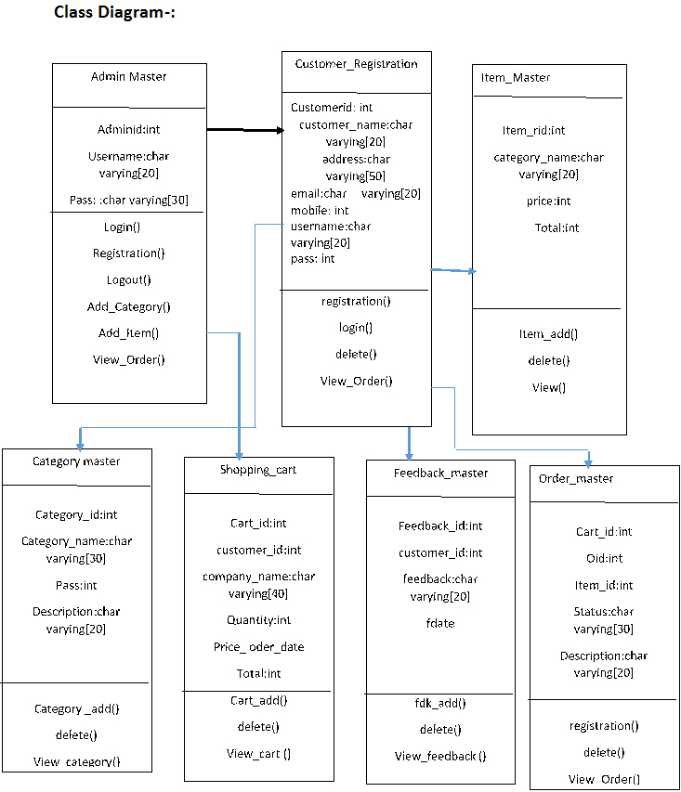

**Use case diagram:-**

Customer

Admin (User)

Database

System service

**Activity diagram:-**

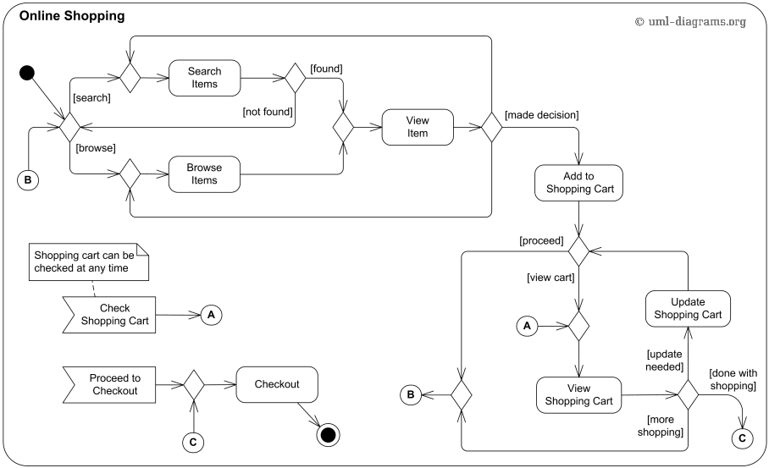

**Sequence diagram:-**

Login

Product

Desc Product

Details scli helper

Database

**Login**

Add product ()

Insert product ( )

Execute New Query ( )

Execute Query ( )

( )

Show Result ( )

Return Response ( )

Response to execute new Query ()

**Component diagram:-**

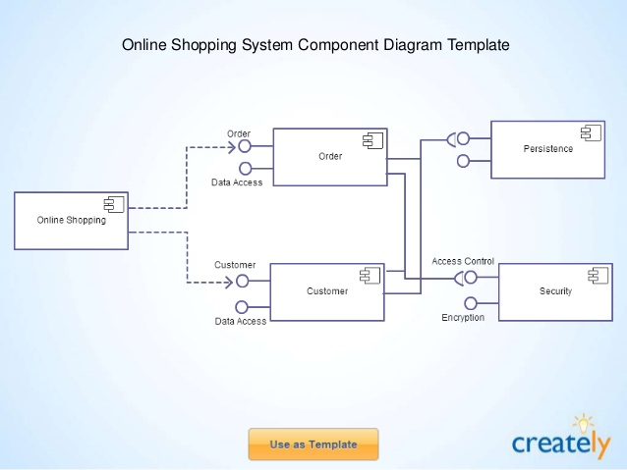

**Deployment diagram:-**

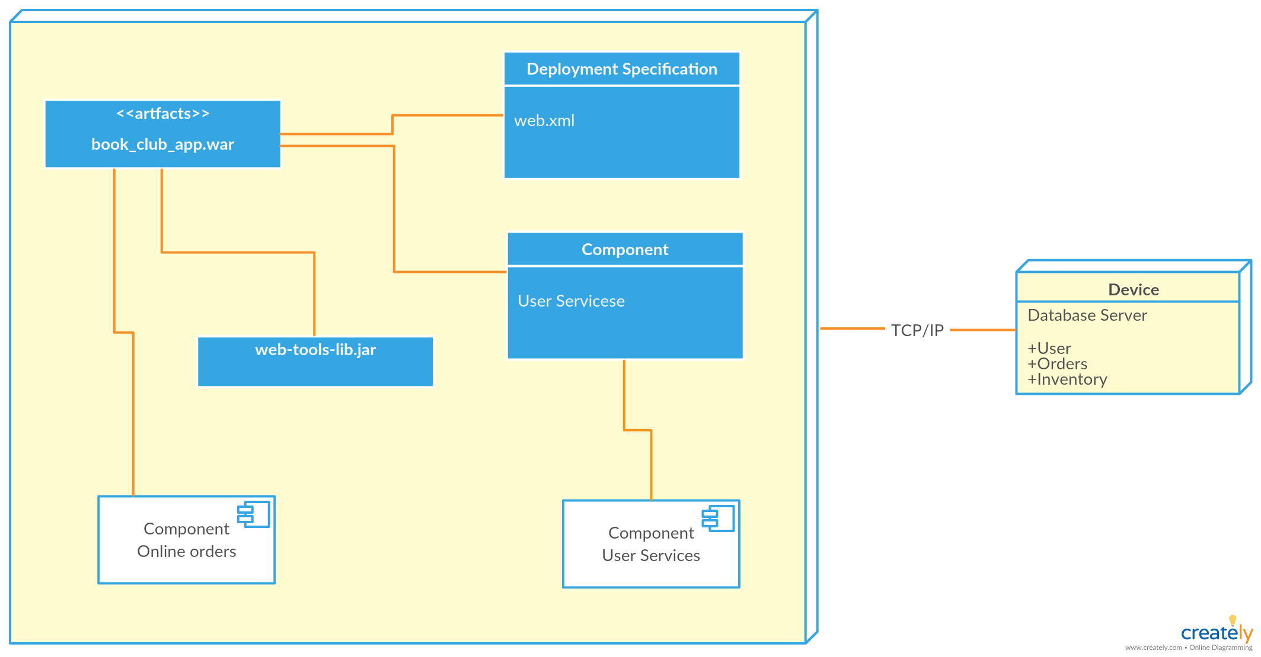

**Data Dictionary:-**

**Customer_registration**

|  |  |  |  |
| --- | --- | --- | --- |
| **Field name** | **Data type** | **Size** | **keys** |
| Customerid | Int | - | Primary key |
| Customername | Text | 20 |  |
| Address | Text | 100 |  |
| City | Text | 20 |  |
| Email | Text | 50 |  |
| Mobile | bigint |  |  |
| Gender | Int | 10 |  |
| Birthdate | Date | - |  |
| Username | Text | 20 |  |
| Password | Text | 20 |  |

**Item_Master**

|  |  |  |  |
| --- | --- | --- | --- |
| **Field name** | **Data type** | **Size** | **Keys** |
| Itemid | Int | - | Primary key |
| Categoryid | Int | - |  |
| Itemname | Text | 20 |  |
| Description | Text | 200 |  |
| Size | Int | 10 |  |
| Image | Text | 100 |  |
| Price | Int | - |  |
| Discount | Int | - |  |
| Total | Int | - |  |

**Shopping_cart**

|  |  |  |  |
| --- | --- | --- | --- |
| **Field name** | **Data type** | **Size** | **Keys** |
| Cartid | Int | - | Primary key |
| Customerid | Int | - | Foreign key |
| Itemname | Text | 20 | Foreign key |
| Quantity | Int | - |  |
| Price | Int | - |  |
| Total | Int | - |  |
| Orderdate | Date | - |  |

**Shopping_cart_final**

|  |  |  |  |
| --- | --- | --- | --- |
| **Field name** | **Data type** | **Size** | **Keys** |
| Cartid | Int | - | Primary key |
| Customerid | Int | - | Foreign key |
| Itemname | Text | 20 | Foreign key |
| Quantity | Int | - |  |
| Price | Int | - |  |
| Total | Int | - |  |
| Orderdate | Date | - |  |
| Discount | Int | - |  |

**Order_Master:**

|  |  |  |  |
| --- | --- | --- | --- |
| **Field name** | **Data type** | **Size** | **keys** |
| Oid | Serial | 10 | Primary key |
| Cart_id | Serial | 20 | Foreign key |
| Item_id | Serial | 50 | Foreign key |
| Status | Character Varying | 25 |  |
| Description | Character Varying | 25 |  |

**System screen:-**

**1)Home page:-**

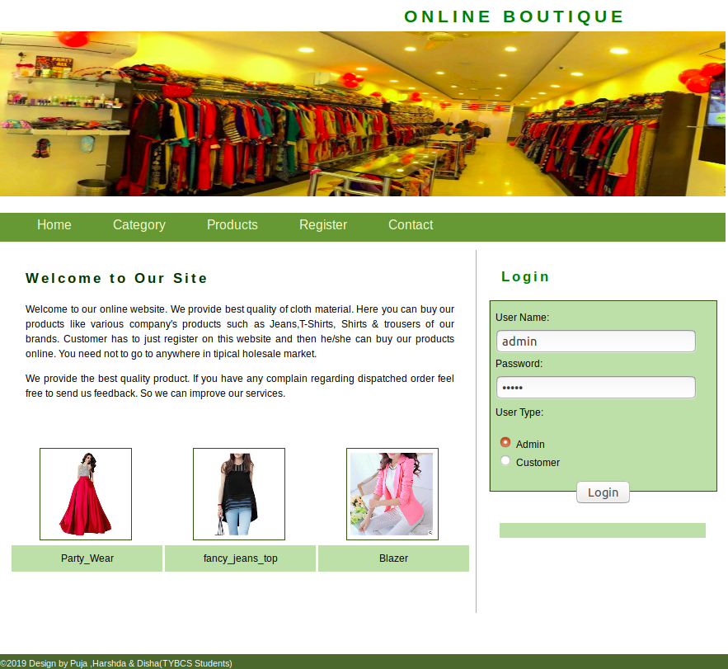

**2)Display all products:-**

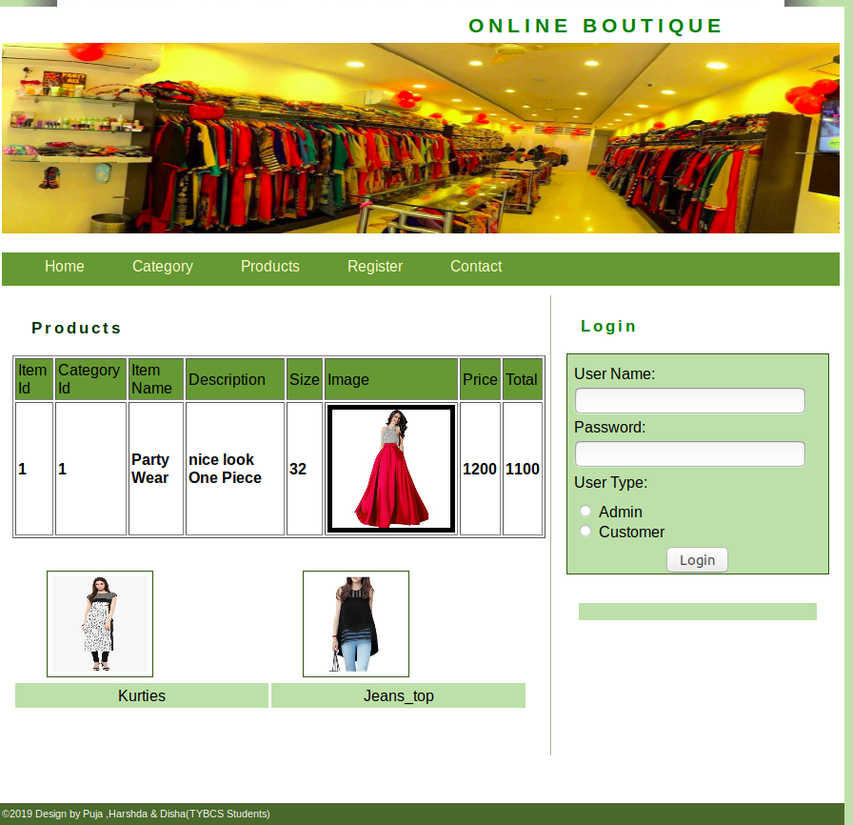

**3)Admin home page:-**

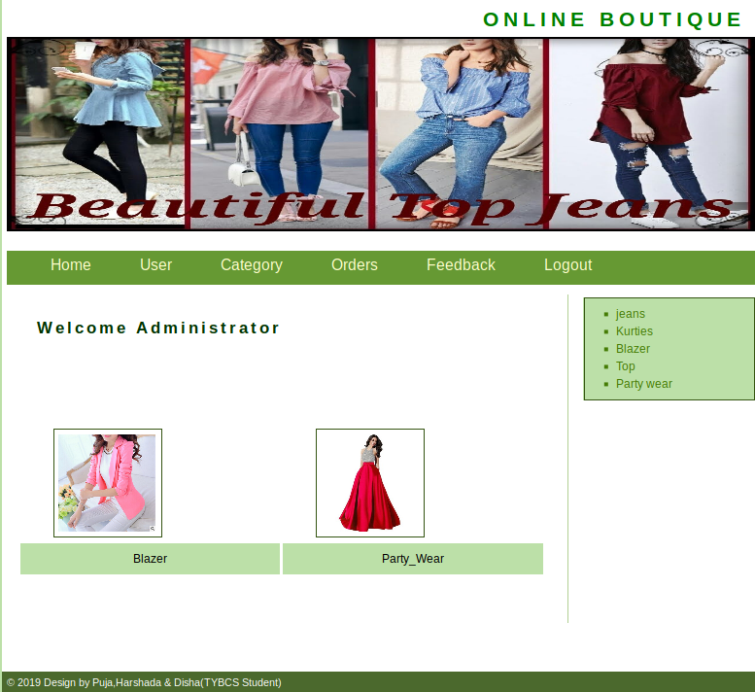

**4)Admin category page:-**

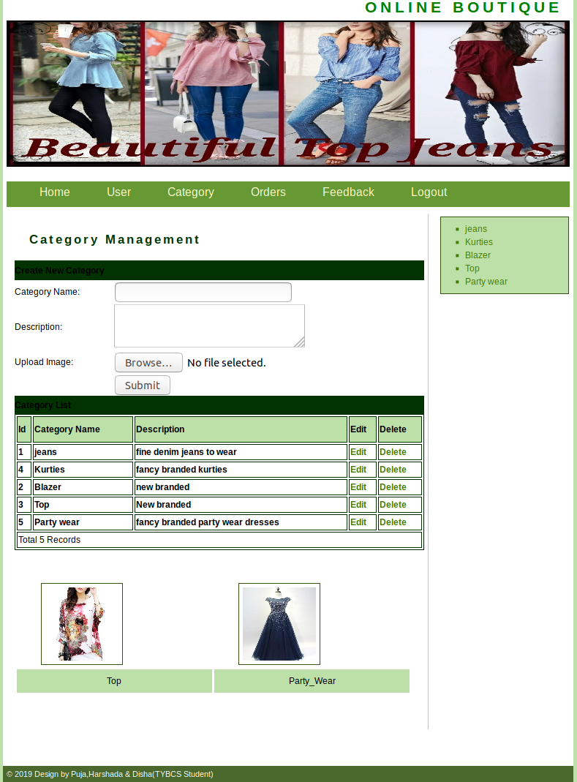

**5)Customer home page:-**

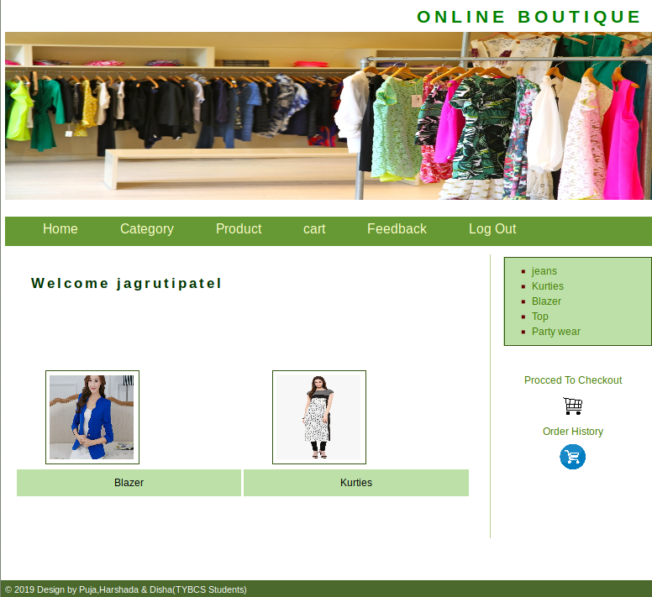

**6)customer cart page:-**

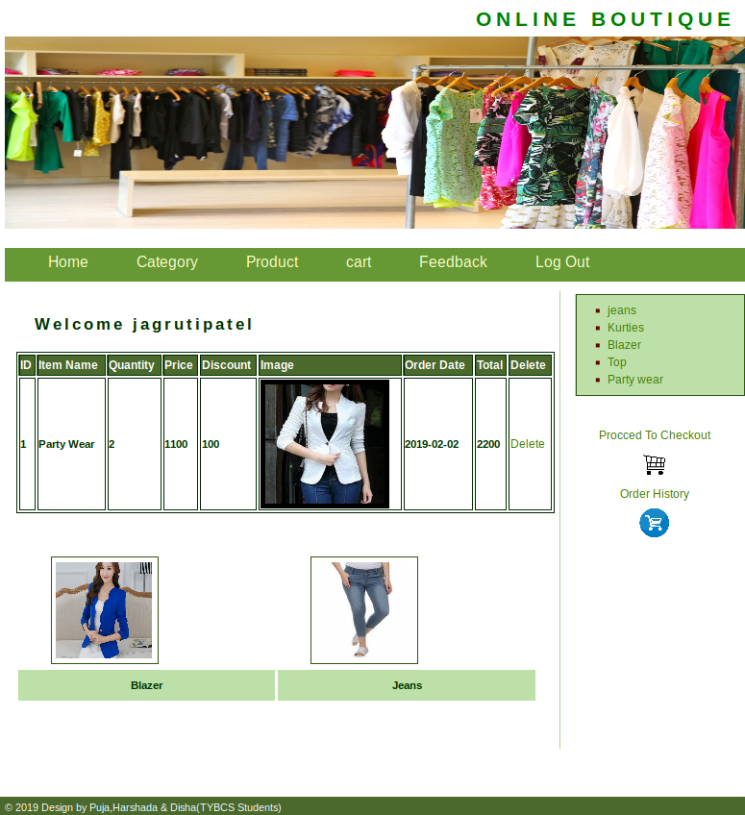

**Testing:-**

The process of executing a system with the intent of finding an error. Testing is defined as the process in which defects are identified, isolated, subjected for rectification and ensured that product is defect free in order to produce the quality product and hence customer satisfaction. Quality is defined as justification of the requirements. Defect is nothing but deviation from the requirements .Defect is nothing but bug. Testing --- The presence of bugs. Testing can demonstrate the presence of bugs, but not their absence. Debugging and Testing are not the same thing. Testing is a systematic attempt to break a program or the AUT. Debugging is the art or method of uncovering why the script /program did not execute properly.

In this system we use four types of testing are newly

1.Black box Testing:

2.White box Testing:

3.Alpha Testing:

1. **Black Box Testing –**

Is the testing process in which tester can perform testing on an application without having any internal structural knowledge of application. Usually Test Engineers are involved in the black box testing. In this testing we can give input and the system gives perfect output if input is right.

**2.WhiteBox Testing –**

Is the testing process in which tester can perform testing on an application with having internal structural knowledge.

Usually The Developers are involved in white box testing.

**3.AlphaTesting –**

It is a type of user acceptance testing, which is conducted on an application when it is just before released to the customer.

# **Future enhancement:-**

# 

* As the technology emerges, It is possible to upgrade the system and can be adaptable to desired environment.
* Because it is based on object oriented design, any future change can be easily adaptable.
* Base on future security issues can be improved using emerging technique.

# 

**Bibliography:-**

**1.** Web database application by Hugh E.Williams

2. Web application with postgres by David Lane

3. Web authoring tools by Al Steven